Assignment No -: 10

Que 1-: Write a query That Produces all pairs of salespeople Who are living in the same city Exclude Combinations of salespeople with themselves as well as duplicate rows with ordered reversed.

kd2_83598>select a.Sname,a.city from salespeople a,salespeople b
-> where a.city=b.city and a.Sname!=b.Sname;
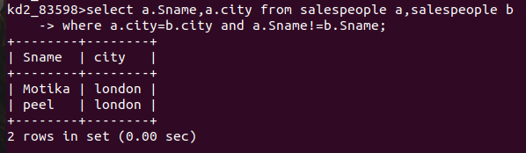

Que 2-: Write A query That Produces The names and Cities of all customers with The Same Rating As Hoffman

kd2_83598>select distinct a.Cname,a.city from Customers a,Customers b
-> where a.Rating=b.Rating and
-> a.Rating=(select Rating from Customers
-> where Cname='Hoffman');
